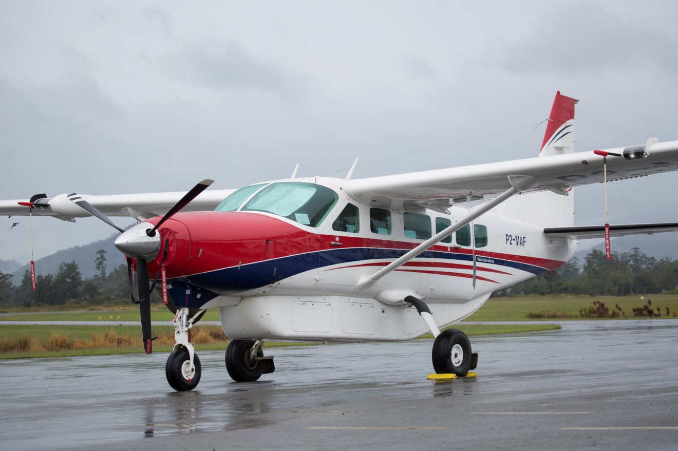

Mission Aviation Fellowship
TRAINING CENTRE
CPL for Papua New Guinea Students

OFFICE USE ONLY
Applicant Name: |  | DATE:
Application Received by: |  | DATE:
Resourcing group: |  | Initial:
Has application form been completed: |  | Initial:
Have all documents been received: | ☐ YES ☐ NO | Initial:

APPLICATION PROCEDURE

- Application
Use the below ‘Checklist for Applicants’ to complete your application and return your full application via email or mail to:

MAF Training Centre  P.O. Box 2296  MAREEBA QLD 4880 | Email: PNG.TrainingCentre@mafint.org  Telephone: +61 7 4092 2744  Facsimile: +61 7 4092 1555

CHECKLIST FOR APPLICANTS
(NOTE: All information needs to be provided in order to avoid processing delays)
☐ Completed all sections of this ‘Application Form’
☐ Attached CV
☐ Attached copies of current aviation licences and ratings / school certificates

- MAF Assessment Centre
If your application is satisfactory to this point, you will receive an invitation to a “Pre-Training Assessment Centre” in Mareeba. This is a 2-3 day event where your capacity for technical and non-technical skills will be evaluated.

- Invitation to start flight training
Pending on a positive result from the assessment centre, you will be put on either the short-list or the waiting-list for a training slot at the Training Centre. This will allow you and MAF to plan when and how you can start your flight training.

PRIVATE & CONFIDENTIAL
The following Application has 3 Sections
- Section 1 - Personal Record & General Information
- Section 2 - References
- Section 3 - Aviation information

Section 1 - Personal Record & General Information

Personal Information
Title (Mr, Mrs, Miss, etc) |  | M ☐ F ☐ | First Name(s)
Surname/Family Name |  |  | Preferred Name
Home Address (including Country)
 |  |  | Post code
Contact Address
(if different from above)
 |  |  | Post code
Daytime telephone |  |  | Evening telephone
Mobile telephone |  |  | E-mail address
Nationality |  |  | City & Country of Birth Click here to enter text.
Date of Birth (Required for pilot enquirers due to age regulations in countries of operation) |  |  |  | Click here to enter a date.
Do you hold a current passport? |  |  | Click here to enter text.
Are there any factors that would prevent you from training in Australia for up to 6 months at a time? Please give details: |  |  | Click here to enter text.
Do you hold a current Driving Licence?
Date of Issue

Education & Skills Record
Please complete the following section; you should attach certificates and details.

Secondary
School or College | Dates | Subject(s) and grade(s)

Higher education details
College or University etc. | Dates | Subject(s) and Qualification(s)

Other skills (e.g. First Aid, IT, driving, vehicle maintenance, playing a musical instrument).
Skills

Overseas experience
Please state the countries you have visited and the purpose of visit e.g. holiday, work, mission trip.
Country & visit purpose

Languages
Please list any languages spoken and level of proficiency.
Language (please specify) | Fluency
 | Choose an item.
 | Choose an item.
 | Choose an item.

*English proficiency will be crucial to Flight Training. The Assessment Centre will test for the required level of English competency.

Financial Resources
Please give details how you expect to cover your financial responsibilities during your time of training:

Duration of course: | __ ____years __ ____months
 | Cost Estimate ($) | How will you expect to cover
Assessment Centre at Mareeba  Travel, Accommodation and living costs  (note: usually only required for CPL courses) |  | Click here to enter text.
Course fees  Refer to Course Information Booklet page 11 Tuition Fees |  | Click here to enter text.
Accommodation and living expenses  Refer to Course Information Booklet page 13 Expenses for Students |  | Click here to enter text.

Please give any additional details: Click here to enter text.

Please note:
Course cost does not include transport, accommodation and living costs. See Course Information Booklet for details.

Employment Record - Please complete the following section; you should include a CV in addition.

Present (or last) employer
Name of employer
Position held
Responsibilities held
Employed from |  | Employed until | Click here to enter a date.
Reason for leaving
Does MAF have permission to contact this employer? | Y or N ?

Previous employer(s)
Name of employer
Position held
Responsibilities held
Employed from |  | Employed until | Click here to enter a date.
Reason for leaving
Does MAF have permission to contact this employer? | Y or N ?

Section 2 - References

Present (last) employer / school
Name |  | Relationship to applicant
Address
 |  | Post code
Telephone |  | E-mail address
Does MAF have permission to contact this employer? |  | Y or N ?

Previous employer / school
Name |  | Relationship to applicant
Address
 |  | Post code
Telephone |  | E-mail address
Does MAF have permission to contact this employer? |  | Y or N ?

Personal referee who has known you for at least three years (not a relative)
Name |  | Relationship to applicant
Address
 |  | Post code
Telephone |  | E-mail address
Date referee can be contacted

Personal referee who has known you for at least three years (not a relative)
Name
Relationship to applicant
Address
 |  | Post code
Telephone |  | E-mail address
Date referee can be contacted

Section 3 - Aviation Experience

Pilot Qualifications / Experience
Flight Training Completed: | Nil ☐ Solo ☐ Area Solo ☐ RP ☐ PPL ☐ CPL ☐
Current Licences Held:  From what country: |  |  | Licence Number
What level of ICAO English Language Proficiency have you been tested to:
Are there any restrictions on your licence? | Choose an item.
If Yes, please give details:
Total Hours Flown: |  | Dual Hours: |  |  | PIC Hours:
 |  | IFR Hours: |  |  | PIC Cross Country:

Current Ratings
NIGHT VFR? | Yes ☐ No ☐
Command Instrument Rating: | Yes ☐ No ☐ M/E ☐ S/E ☐
List aids for which endorsed:
Endorsed on Aircraft Types:

CPL Theory
Have you successfully completed any CPL/IFR Theory Exams already? (Australian or other) Yes ☐ No ☐
Meteorology CMET Date Passed: Click here to enter a date. | Navigation CNAV Date Passed: Click here to enter a date.
Air Law CLWA Date Passed: Click here to enter a date. | Performance CFPA Date Passed: Click here to enter a date.
Human Factors CHUF Date Passed: Click here to enter a date. | General Knowledge CSYA Date Passed: Click here to enter a date.
Aerodynamics CADA Date Passed: Click here to enter a date. | Instrument Rating Theory Date Passed: Click here to enter a date.
Aviation Medical
Current class of Medical: Class 1 ☐ Expiry Date: Click here to enter a date. Class 2 ☐ Expiry Date: Click here to enter a date.
Are there any restrictions on your Medical? | NO ☐ YES ☐ If Yes, please detail;

Declaration
I declare to the best of my knowledge and beliefs, all particulars I have given are complete and true. I understand that any false declaration or misleading statement or a significant omission may disqualify me from the selection process or later from continuing the course. I agree to Mission Aviation Fellowship processing this information under the terms of current data protection legislation.
Signed |  | Date

